1. (5分) Answer the following questions:
(1) Please write down three types of power diodes.
(2) Which type are Thyristor and IGBT, current-driven device or voltage-driven device?
(3) Why the MOSFET can be easily paralleled to conduct higher current .
(1) 功率二极管分哪三种类型？(2分)
(2) 分别说出晶闸管和IGBT属于电压控制还是电流控制型器件？(2分)
(3) 为什么MOSFET器件容易实现并联均流？(1分)

答案：
(1) 功率二极管分为普通整流二极管、快恢复二极管、肖特基二极管。
(2) 晶闸管属于电流控制型器件，IGBT属于电压控制型器件。
(3) MOSFET能够并联使用提高通流能力，是因为MOSFET的通态电阻具有正的温度系数，即通态电阻随温度升高为增大，因此具有均流的作用(电流大→温度升高→电阻增大→电流减小)。

2. (4分) The switching waveforms of a power electronics device are shown in Fig.1. If V_{o}=50V, I_{o}=10A, on-state resistance is 20mΩ. The turn-on delay and turn off delay time are neglected. Answer the following questions:
某一电力电子器件的开关波形如图1所示。如果V_{o}=50V, I_{o}=10A，通态电阻为20mΩ。忽略开通延迟和关断延迟时间。回答以下问题。
(1) What is the switching power loss of the switch? 开关管的开关损耗是多少？(2分)
(2) What is the total power loss of the switch? 开关管的总损耗是多少？(2分)
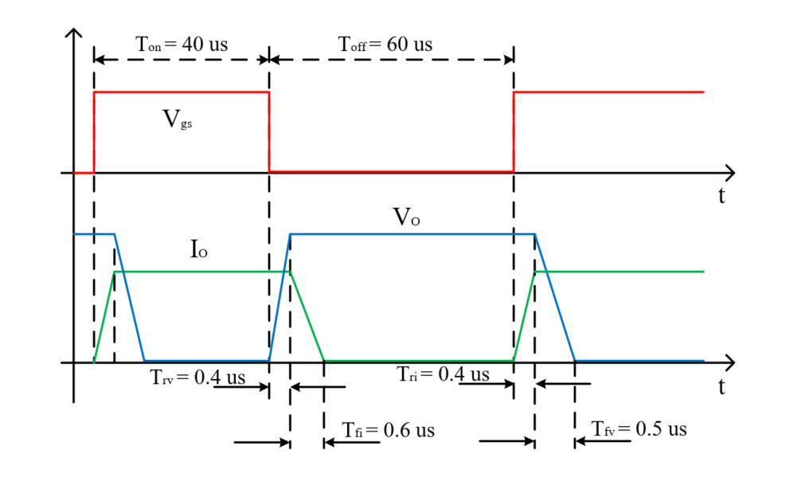
Fig. 1 Switching waveforms of a power electronics device
答案：
(1)
Ps=4.75W
(2) Pon=0.782W
P=Ps+Pon=5.532W
3. (8分) In a Buck converter, consider all components to be ideal. Let input voltage V_{d} be 50~80V, output voltage V_{o} = 40V, and L=60μH, f_{s} = 40kHz. 在Buck变换器中，考虑所有元件都是理想的。设输入电压V_{d}为50~80V，输出电压V_{o}为40V，L=60μH，开关频率为40kHz。
(1) Draw the Buck converter circuit diagram. 画出Buck变换器电路图。(1分)
(2) Draw the waveforms of v_{L}、i_{L}、i_{C}. 画出v_{L}、i_{L}、i_{C}的波形。(2分)
(3) Calculate the minimum output power P_{omin} that will keep the converter operating in a continuous-conduction mode for all range of V_{d}. 计算全输入电压范围内能够使变换器工作在CCM模式下的最小输出功率P_{omin}。(3分)
(4) What will happen if keep D=0.5 and the load R is open? 如果占空比固定而负载突然开路，会出现什么结果？(1分)
(5) Which is big for the Switch utilization in condition of D=0.2 and D=0.8？比较在D=0.2和D=0.8两种情况下哪个开关利用率高？(1分)

答案：
(1) Buck变换器电路图：
(2) v_{L}、i_{L}、i_{C}的波形：
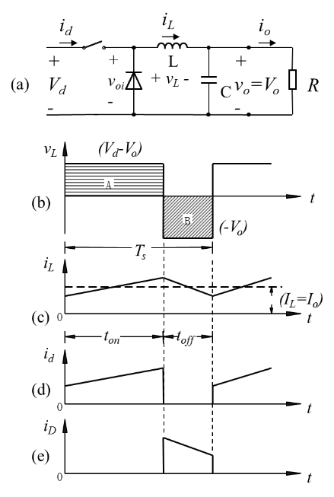
(3)计算最小输出功率P_{omin}：
V_{o} =DV_{d}，V_{d} =50~80V，V_{o} =40V，D=0.5~0.8，
V_{o} =40V，L =60uH，T_{s} =25us，取最小值D =0.5，
代入得I_{oB}=4.16A，
P_{omin} =V_{o} *I_{oB} = 166.6W
(4)如果占空比固定而负载突然开路，输出电压会升高，直至输出电压等于输入电压；
(5) D=0.8时开关利用率高。

4. (8分) In a Buck-Boost converter, consider all components to be ideal. Let input voltage V_{d} = 24V, D=0.6, and L=100μH, f_{s} = 50kHz, P_{o}=360W. 在Buck-Boost变换器中，假设所有元件都是理想的。设输入电压V_{d}= 24V，占空比D=0.6，电感为100μH，f_{s} = 50kHz，P_{o}=360W。
(1) Draw the Buck-Boost converter circuit diagram. 画出Buck-Boost变换器电路图。(1分)
(2) Derive the relationship between the output voltage V_{o} and input voltage V_{d,} when the inductor current is continuous. 推导电感电流连续时输出电压V_{o}与输入电压V_{d}之间的关系式。(2分)
(3) If the output voltage ripple ratio ∆V_{o}/V_{o} is less than 2%，please calculate the minimum value of C in this converter. 如果输出电压纹波比∆V_{o}/V_{o}小于2%，请计算该变换器中电容C的最小值。(2分)
(4) What is the voltage stress of the switch? 开关管的电压应力是多少? (1分)
(5) What is the advantage and disadvantage of this converter? 该变换器的优缺点是什么？(2分)

答案：
(1) Buck-Boost变换器电路图：
(2) 输出电压V_{o}与输入电压V_{d}的关系式根据伏秒平衡推导：
(3)
V_{o}=36V， ∆V_{o}/V_{o}<2%， ∆V_{o}=0.72V
P_{o} =360W， V_{o} =36V ，I_{o} =10A，T_{s} =20us，D =0.6，
代入得 C_{min} = 166.6 μF
(4)开关管的电压应力： V_{T}=V_{d}+V_{o}=24+36=60V
(5) 优点：电路可升压可降压。缺点：输入和输出反极性，开关管的电压、电流应力较大。

